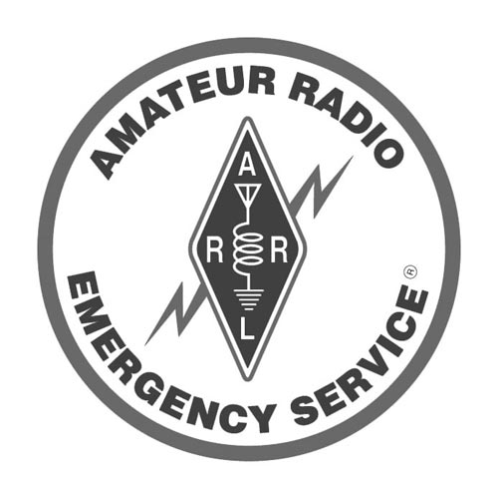

Memorandum of Understanding
between
Anderson County Amateur Radio Emergency Service (ARES®)
and
Anderson County and the Office of Emergency Management (OEM)

I. Introduction

The Amateur Radio Emergency Service (ARES®) is composed of amateur radio operators, who have volunteered their capabilities and equipment to provide supplementary communication in time of public need.

Amateurs are licensed by the Federal Communication Commission (FCC) after passing a written examination on their knowledge of telecommunication and technical skills in the operation of radio equipment.

In accordance with treaties agreed under the International Telecommunication Union (ITU), frequencies throughout the radio spectrum are allocated to the amateur radio service. By selection of appropriate frequency bands, amateurs are capable of communications around the world, throughout a geographical region, or may be limited communications to only a local area.

All nations allocate valuable space in the radio spectrum to the amateur radio service, because of its ability to immediately respond in the time of need and quickly establish communications where none existed or to supplement existing emergency radio services overloaded with disaster communications.

Under FCC rules and regulations, amateurs may not be compensated for providing communications and are prohibited from providing communication that furthers the conduct of any business. An exception is defined for the paid broadcast engineer, who is a licensed amateur, who communicates on amateur frequencies in accordance with emergency operation plans.

II. Organizations

- Amateur Radio Emergency Service (ARES®)
ARES® is sponsored by the American Radio Relay League (ARRL) to provide supplementary or emergency communications for public service purposes other than civil preparedness. Agencies served include the American Red Cross, the Civil Air Patrol, the Salvation Army, law enforcement, city and volunteer fire departments and/or other government agencies as needed. In all instances in this MOU, it is understood that ARES® is a registered trademark of the ARRL.

- National Weather Service (NWS)
The NWS sponsors Operation SKYWARN and trains amateur radio operators as spotters during severe weather and thunderstorms.

- National Traffic System (NTS)
The NTS is sponsored by the ARRL to provide a network of local, state, area, and transcontinental radio circuits for the transmission of non-commercial message traffic in support of the public interest.

- Military Affiliate Radio System (MARS)
MARS is a radio communications service of licensed amateurs who are affiliated with the Department of Defense military services (Army, Navy, and Air Force) as an adjunct to military communications.

III. Authority

Title 47 U.S.C. 151, 145(I); Chapter 1, Part 97, Subpart A, Sections 97.1, 97.89,
97.91, 97.107 and Subpart F (all); Federal Communications Commission Rules
and Regulations, Amateur Radio Service.

IV. Purpose

The purpose of this Memorandum of Understanding (MOU) is to provide an understanding for the authorization and mobilization of volunteer amateur radio operators when needed in a communications emergency.

- ARES® may supply communication services where no established
links exist or supplement existing system(s) if they are overloaded or disabled, such services may include the following:

  - Communications between Anderson County, the City of
Palestine, the City of Frankston, the City of Elkhart as well as
state and federal agencies.

  - Intercommunications among county, private, and public service
organizations.

  - Additional public service communication.

  - Health and welfare communications inside the state and most anywhere in the world.

- A secondary purpose of ARES® is to provide non-emergency
communications for city and county agencies and services or other qualified organizations at the discretion of the ARES® officer.

V. Method of Cooperation

In order that the emergency communications of ARES® and NTS may be coordinated and utilized to the fullest advantage during disasters, Anderson County and the Office of Emergency Management (OEM) agree to the following:

- Through its leadership, Anderson County ARES® will establish a
regular liaison with Anderson County and the OEM. The liaison will provide cooperation and direct operational assistance with regard to emergency communications planning, and the coordination of amateur radio communications personnel, equipment and/or facilities for relief operations.

- Anderson County and the OEM welcomes the cooperation and
assistance of Anderson County ARES®, to extend emergency communications coordination and planning, into the jurisdiction of Anderson County and the OEM.

Anderson County and the OEM will be urged to further the cooperative effort, by requesting Anderson County ARES® and NTS personnel serve as disaster volunteers for emergency communications. Such personnel will be expected to report to the ARES® Emergency Coordinator (EC) of said jurisdiction.

ARES® and NTS volunteers will be encouraged to take part in pre-disaster training and planning, work with Anderson County and the OEM to provide amateur radio communications equipment and volunteers, and to meet the needs of disaster communications plans.

- When a disaster occurs requiring the use of amateur radio
communications, the Anderson County OEM, through an individual representative and with the understanding of the agencies to be served, may recommend the assistance of ARES® near the scene of a disaster. This assistance may include, but is not limited to the following:

  - The alerting and mobilization of amateur radio volunteer
emergency communications personnel in accordance with a prearranged plan.

  - The establishment and maintenance of fixed, mobile, and/or
portable station emergency communication equipment for local
radio coverage, and point-to-point contact between public
safety officials and locations as required.

  - Maintenance of the continuity of communications for the
duration of the emergency period or until normal
communications channels are substantially restored.

- Anderson County ARES® agrees to supply the Anderson County OEM
with lists of emergency communicators on an annual basis. The
Anderson County OEM agrees to supply Anderson County ARES®
with pertinent information and points of contact at various locations on
an annual basis

- Detailed operating plans for the utilization of the communication
facilities of the amateur radio service shall be developed with the Anderson County OEM in cooperation with local ARRL, ARES® and NTS personnel.

- Anderson County and the OEM will request representation from the
local ARES® and NTS organizations for input and discussion with regard to disaster preparedness with emergency communications.

- Approved Anderson County ARES® volunteers will have ARES® credentials issued to them by the ARES®-EC for identification purposes.

- Anderson County and the OEM will recommend a standing
committee be appointed within the organization as a means of
maintaining liaison with local ARES® officials. The Anderson County OEM will recommend local ARES® officials be admitted to appropriate Anderson County training classes.

- Each organization will distribute copies of this MOU through its field
structure and make copies available to other organizations, both public
and private, which may have an active interest and participation in
disaster relief operations.

VI. Term of Agreement
This agreement is effective as of the date indicated below, and shall remain in effect unless terminated by written notification from either party to the other; or, until replaced by an updated version mutually agreed to by both parties.
Date of Agreement: 02-06-2006

_____________________________________ __________________
Linda Ray Date
Anderson County Judge

_____________________________________ __________________
Chuck Franklin Date
Anderson County Emergency Management Coordinator

______________________________________ __________________
Jeff Montgomery WB4WXD Date
Anderson County ARES Emergency Coordinator

